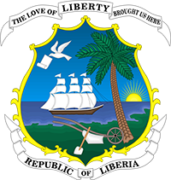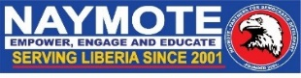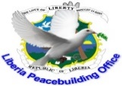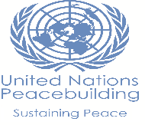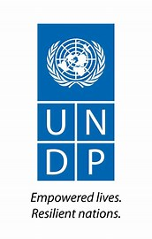

**REPORT FROM**

**National Peace & Reconciliation Conference in Liberia**

**Theme: “Enhancing Social Cohesion and Reconciliation at National and County Levels”**

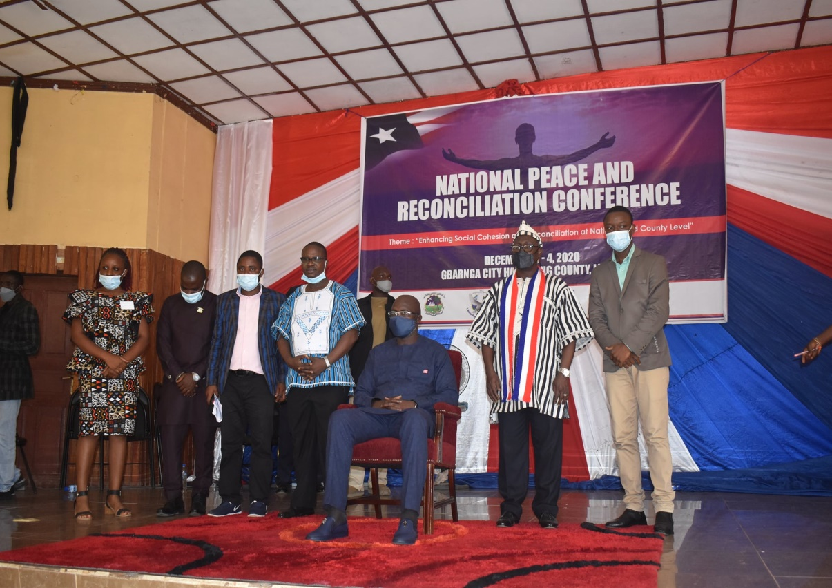

Organized by:

**Naymote Partners for Democratic Development**

**In collaboration with Ministry of Internal Affairs, R.L.**

**Sponsored by: UNDP**

**Gbarnga Administrative Building**

**Gbarnga City, Bong County**

**December 3-4, 2020**

Table of Contents

I. Background/Introduction 3

II. DAY ONE (1) – December 3, 2020 3

1. Opening Session 3

2. Panel Discussion I: Political Reconciliation and decentralization / inclusive governance-the way forward 5

2.1 Q & A 6

2.2 Comments 6

3. Panel Discussion II: Presentations of County Reconciliation Plans for securing and sustaining Grassroots Reconciliation Initiatives in Liberia 6

3.1 Montserrado: 6

3.2 River Gee: 6

3.3 Grand Bassa: 7

3.4 Grand Kru: 7

III. DAY TWO (2) 7

1. Panel Discussion I: Presentations of County Reconciliation Plans for Securing and Sustaining Grassroots Reconciliation Initiatives in Liberia Cont’d: 7

1.1 Maryland - Issues/Key Objectives Outlined And Recommendations For Way Forward: 7

1.2 Bomi - Issues/Key Objectives Outlined And Recommendations For Way Forward: 8

1.3 Gbarpolu - Issues/Key Objectives Outlined And Recommendations For Way Forward: 8

2. Panel Discussion II: Economic Empowerment for Women and Youth to Enhance Social Cohesion and Peace building; 9

3. Session III: Group Work on the Implementation of County Plans to support Reconciliation, Governance, and Accountability 9

4. PRESENTATIONS: 10

4.1 GROUP ONE 10

4.2 GROUP TWO 11

4.3 GROUP THREE 12

4.4 GROUP FOUR 13

5. SESSION IV: Sustainability Plan in support of the implementation of the County Plans and plans to roll out the implementation of the 7 counties plan 14

6. SESSION V: The National Peace and Reconciliation Resolution 14

IV. CONCLUSION 17

# Background/ Introduction

Naymote Partners for Democratic Development in collaboration with the Liberia Peacebuilding Office and Ministry of Internal Affairs successfully organized and held two days National Peace and Reconciliation Conference from December 3-4, 2020 at the Gbarnga City Hall in Bong County, Liberia, under the theme: “Enhancing Social Cohesion and Reconciliation at National and County Levels”. Conference was sponsored by the United Nations Development Programme (UNDP).

The primary goal of the conference was to also enhance local voices for consolidation of peace in Liberia. Moreover, the conference focused on way to achieving genuine peace and the implementation of the consolidated reconciliation plan and road map, which derived from the TRC recommendation.

The National Peace and Reconciliation Conference was presided over by H.E. Dr. George Manneh Weah, President of the Republic of Liberia, with representation from Government Ministries, Agencies, and Commissions, with delegations drawn from the seven counties, traditional and Religious Leaders, Civil Society Organizations, Women and Youth Organizations, and witnessed by international partners including UN, ECOWAS amongst others; H.E. Dr. George M. Weah delivered the Keynote Address; he endorsed the fifteen (15) Counties Consolidated Peace and Reconciliation Plan and pledged his government commitment to ensuring the plan is fully implemented. The conference brought together total of 142 participants (105 males and 37 females). Members of the diplomatic corps and international partners, Superintendents from seven counties, local officials local officials and delegates from 7 counties, traditional leaders, county administrators, youth and women leaders, civil society leaders, the media and security forces, etc. were fully represented.

Thematic panel presentations and plenary discussions addressed the following issues: (1) Political reconciliation and decentralized/ inclusive governance – The way forward; (2) Presentation of County Reconciliation Plans for Securing and Sustaining Grassroots Reconciliation Initiatives in Liberia (Montserrado, Rivergee, Grand Bassa, Grand Kru, Maryland, Bomi, Gbarpolu); (3) Economic Empowerment for Women and Youth to Enhance Social Cohesion and Peacebuilding; (4) Implementation of county plans to support reconciliation, governance and accountability; (5) Sustainability – potential commitment to support implementation of the county plans.

Conference participants reaffirmed their commitment to finding durable solutions to reconciliation, security and development challenges, in order to sustain peace and stability. At the end of the conference, a resolution was developed and adopted by participants.

# DAY ONE (1) – December 3, 2018

## Opening Session

The proceedings of Day 1 began with an opening ceremony, which started with invocation done by Rev. Nimely, Religious Advisor to the President and welcome remarks by the Superintendent of Bong County, Hon. Esther Walker. During her welcome remarks, she turned the power over to the Minister of Internal Affairs, Hon. Varney A. Sirleaf who then turned same over to the President of the Republic of Liberia, H.E George Mannah Weah. The President of Liberia then declared the conference opened. Hon. Varney A. Sirleaf, giving the background of the conference mentioned that reconciliation is necessary for development and to achieve it, we all need to get involved with the process. He also said as Liberians are on the path to reconciliation, it should begin with one self. Remarks were done by Ms. Loretta Pope-Kai, Chairperson, National Civil Society Council of Liberia, Amb. William Richard Tolbert, III, National Peace Ambassador, Hon. F. Musa Dean, Minister of Justice, Josiah Marvin Cole, Secretary General of Bong County Caucus, Hon. Janjay Biakpeh, Superintendent, Grand Bassa County and Chair Superintendents Council amongst others. They all pledged their support to working towards achieving genuine peace and reconciliation in Liberia. His Excellency, Dr. Kingsley Armaning, UN Resident Coordinator and H.E. Babatunde O. Ajesomo, Special Representative of the President of ECOWAS, Ambassador of ECOWAS also made special statements. They committed their institutions to supporting the Liberia peace process and stated that they will always be available once it is about the protection of human rights.

His Excellency, Dr. George M. Weah, President of the Republic of Liberia delivered the Keynote address. He endorsed the 15 counties consolidated peace and reconciliation plan and called on all Liberians to support the national consolidated peace and reconciliation plan and pledged his government’s commitment to ensuring that the plan is fully implemented. He concluded by urging Liberians to join him in peacebuilding because conflicts devastate lives.

The Opening ceremony ended with a vote of thanks done by Mr. Edward K. Mulbah, Executive Director of the Liberia Peace Building Office. He thanked the President for his efforts and steps taken towards genuine reconciliation in Liberia, and all the speakers for sharing their respective thoughts and insights on reconciliation.

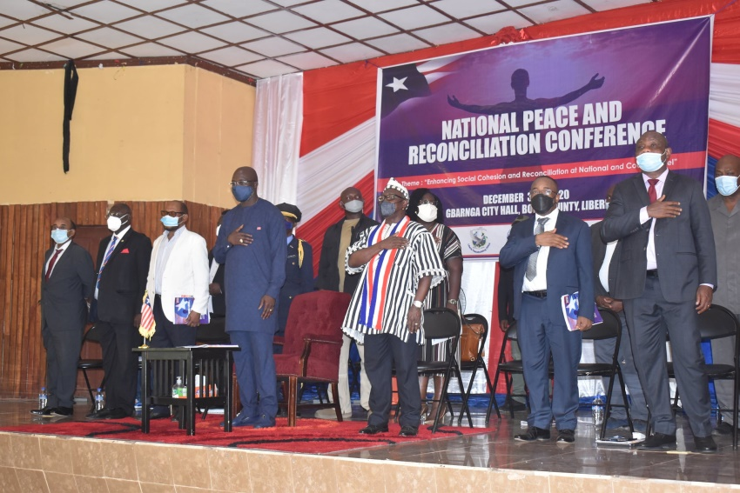

**President George Manneh Weah and Delegation**

## Panel One Discussion: Four panellists discussed the Political Reconciliation and decentralization / inclusive governance-the way forward

This session was moderated by Mr. Franklin O. Siakor

**Rev. Kollie** spoke about reconciliation and its definition. He also listed the types of Reconciliation: Political, Social, and systemic change. He also said Politics have moral indication and politician should be careful how they handle issues to avoid problem. He said systemic change is key to promoting structure reconciliation.

He mentioned that political participation is complex in the governance of the country, and at such, partisans should be given the time to have frank discussions across the table and resolved some of the issues at stick. Politicians should reconcile all of the time and work with political parties for the good of the country. He also stressed the need for government to ensure the election of superintendents and other local leaders as provided by the LGA. In all that we do, Liberia should be prioritized-let’s not seek confusion as the best way of handling our disputes, but instead frank conversation with open-mind.

**Malcolm Joseph (Second Speaker**): Reconciliation should be on the basis of honesty and self-declaration, and not for the need to satisfy policy crafting. Political will is as important as any other to promoting reconciliation. He pointed that political will play a major role in the execution of political reconciliation. It must be demonstrated from above. It must exist at all times and in every government. Reconciliation should be decentralized because the issues at stick are with the followers of politicians. Superintendents of various counties across the country should also take the lead in working with local leaders to reconcile amongst themselves. By this, the people will be reconciled and development will be fast-strike. We have a perfect roadmap but we should firstly demonstrate political will.

Access to justice is key to political reconciliation. Government need to ensure that citizens have equal access to justice. During the questions and answers segment, the speaker underscored the ardent need for national government to be committed to promoting reconciliation if either of the two means of reconciliation (Button-to-Top, Top-to-Button) must be achieved. Let us be genuine and truthful to ourselves, he closed.

**During Rev. William R.Tolbert III** deliberation, he said, during dialogue to resolve conflict, leaders should encourage people to speak so that the main problem can be known. He said, when what they will say is not good, they should be told why and we should all agree to work together. He also highlighted that reconciliation can be bottom to top approach or top to bottom approach and further mentioned that if citizens see the need to reconcile, they should do it and don’t wait for leaders. He urged citizens to initiate the change, start the conversation before it gets big. Rev. Tolbert also mentioned that citizens should encourage dialogue because people might be interested in the reconciliation process. He concluded that reconciliation requires everyone to get involved and when we are honest about what we preach about reconciliation then, it will be achieved.

**Rev. Richard Tolbert (Third Speaker):** Reconciliation can be championed in two-force; Top-to-button or Button-to-Top approach. In the case of Liberia, we should use the Button-to-Top approach where citizens can initiate the process and have national government as the decision making body. Self-respect, tolerance and respect for the rule of law will further strengthen reconciliation.

Jeremiah Swen, National Civil Society Council of Liberia-Delegates: Geopolitics is not morality; it is about strategic interest and we will need to critically look at if we should reconcile ourselves. If not looked at, I fear that we will not achieve in our quest to reconcile the country since this is where people do everything to satisfy their personal interest even if it will mean to dehumanize their fellow men.

### Q & A

1. Why it is that reconciliation process will only stop in 2 counties, what happened to the rest?

A: This is a pilot project and it will be moved to all counties later, awaiting donor funding

1. What can we do now so that the system can be worked?
2. How can we sustain the peace when there are contradictions in the justice system.
3. How can we reconcile when people abuse power?
4. How can we find total peace when there is conflict at county level

### Comments

1. When it comes to genuine reconciliation, it is good for us to start with the leaders then they will take it to their followers.
2. Nothing in politics about morality or people feeling bad.

## SESSION II Discussion: Presentations of County Reconciliation plans for securing and sustaining Grassroots reconciliation Initiatives in Liberia

These presentations were done by four (4) counties; namely Montserrado; River Gee, Grand Bassa, and Grand Kru and presided over by Mr. Franklin O. Siakor and Moses Bailey, ZOA’s Program Officer

### Montserrado County:

Montserrado emphasized on the lack of public trust in the criminal justice system is undermining the peace and leading to the commission of crimes in Montserrado. The commission of crimes is skyrocketing and it is because of the high intake of drugs by especially the youthful population. To curtail this, Montserrado recommends that the drug law be repeal and made a non-billable offense. Rape and Gender-based violence is on the increase as well and we need more awareness in our county to minimize its increase. CSDF needs more awareness that will enable local leaders understands their roles and increase participation by local leaders. Local dialect jingles aired on community radio stations will help.

### River Gee County:

River Gee County stressed on the need to Increase citizens trust by identifying the role of justice actors in the criminal justice system and regular meetings held with justice actors and presided over by the county’s leadership to address some of the reasons responsible for lack of citizen’s trust. Land issue is also a problem. The LLA should make copies of the Land Rights Acts and ensure their airing on community radio stations. Accountability is a huge challenge and advocacy and engaging lawmakers are paramount to achieving this. We should ensure the passage of the standalone budget law to reduce lawmakers influence on the management of the CSDF. To reduce rape cases which has become a creeping nightmare in River Gee, the MOG must redefine its role and ensure that the issues affecting women are documented and perpetrators be brought to justice.

### Grand Bassa:

Cataloged issues focused on the rule of law and noticed that citizens are denied justice and that social cohesion is lagging. Medication-limited or lack of quality health care system; Violence against women and girls; poor accountability and the budget law is not adhered to; and the need to increase the presence of more police officers in order to minimize the commission of crimes.

### Grand Kru County:

Grand Kru County reportedthatcivil society actors, local government officials and the ordinary citizens need to work together with support from development partners to reduce the commission of rape cases and Gender-based violence; reduce land and boundary conflicts that are on the increase in our county. We are experiencing external and international land disputes. Traditional leaders are also claiming ownership of the land. Inequitable distribution of the county development found even though the money is insufficient. They opted to conducting potential employment opportunity mapping were young resourceful people will be recorded and employed in case of vacancy. The discussion highlighted: External Land conflict/ Internal, Equality, Bureaucracy is too much for the county development fund-it becomes difficult sometimes.

# DAY TWO (2)

## Session I: Presentations of County Reconciliation Plans for Securing and Sustaining Grassroots Reconciliation Initiatives in Liberia Cont’d:

This session was presided over by Moses Bailey, Program Officer – ZOA and selected members of the county delegates presented and validated their plans as follows:

### MARYLAND COUNTY - Issues/Key Objectives Outlined And Recommendations For Way Forward:

The issues surrounding the increase of access to justice where private lawyers are hardly seen in Maryland County; Land and boundary conflicts; lack of proper accountability in the usage of the County Development Fund (CDF) and County Social Development Fund (CSDF) and the management of the county payroll; Increased employment for citizens; particularly, and youth employment;

The following recommendations were made:

* That the government of Liberia encourages more legal professionals, private lawyers, to take assignments in the county; that the Ministry of Internal Affairs and the Liberia Land Authority ensure an amicable handling and/or resolution of all land disputes in the county;
* That the GoL increase accountability in the management of CDF and CSDF;
* That the payroll harmonization process be decentralized to avoid employees travelling from the county to Monrovia for redress on salary issues; and
* That government should engage the private sector, mainly mining, in identifying more job opportunities for the youth

### BOMI COUNTY - Issues/Key Objectives Outlined And Recommendations For Way Forward:

Bomi County highlighted the issues of increased citizens’ access to justice; increased citizens’ access to inclusive service delivery in the areas of Health and Education; Increase accountability in the management of CDF and CSDF; reduce violence against women; and increased in employment opportunities for young people.

Bomi County made the following recommendations:

* That the Civil Society Organizations (CSOs) engage the major actors of institutions within the Criminal Justice System to ensure that criminal court cases such as rape are properly adjudicated and that feedbacks are provided to the Judiciary in a timely manner;
* That government fast track the remittances of development funds intended for the county are done in time to ensure easy access to affordable services to mainly poorer communities;
* That government institute measures that will avoid and/or prevent the interferences of lawmakers with the management of County Development Funds;
* That there should be a major stakeholders’ collective approach through community mobilization and that a law be passed by the National Legislature for rape to be “None billable offense; and
* That county officials engage the Legislative Caucus of the county and the Bureau of Concessions to enforce employment provisions as contained in the Concession Agreements.

### GBARPOLU COUNTY - Issues/Key Objectives Outlined And Recommendations For Way Forward:

Finally, the below issues were also raised by Gbarpolu County:

Border security with the Sierra Leone, continuous land disputes between Gbarpolu and Bong Counties on one hand and Gbarpolu and Bomi Counties on the other hand, citizens’ access to affordable health and education services, accountability in the management of County or Social Development Funds, violence against women, and the issue of illicit extraction of resources within the mining sector.

In conclusion, these recommendations were made:

* That the Government of Liberia increase security personnel presence in the county and provide them with adequate logistical support;
* That government act swiftly in mitigating the land issues among the three counties in order to maintain peace and genuine reconciliation;
* that stakeholders advocate and monitor the allocation of funds in the National Budget for the provision of needed social services mainly those gear towards health and education programs in the County;
* That county officials lobby and advocate with relevant government institutions for a change or an amendment of the Budget Law concerning the management of County and Social Development Funds;
* That the Government of Liberia develop a strong mechanism for a collective approach through community mobilization to educate women on the danger of drugs abuse and advocate for perpetrators of rape cases be dealt with in keeping with the laws of Liberia; and
* That major stakeholders of the county work with the Ministry of Mines and Energy and the Bureau of Concession to ensure the enforcement of the Mining Law of Liberia

## Panel I Discussion: Economic Empowerment for Women and Youth to Enhance Social Cohesion and Peace building;

This Discussion was moderated by Mr. Jeremiah S. Swen-Secretary General, Civil Society Council of Liberia, Mr. Roland Clarke-Director NCCRM, Tonia A. Tarley-Wiles, Commissioner,INCHR and Ms. Gwendolyn Myers, Executive Director, Messengers of Peace-Liberia, Inc were panelists.

**During their discussion,** theyhighlighted that young people should be involved with the peace process. They should not only be used but should be called to the dialogue tables to bring forth their ideas. She further mentioned thatyoung people should be leading mediation; they should not just be participants. If it is not important, the UN will not spend on different three agenda.If young people reject peace in any country, it will not be achieved. Young people should be involved. They recommended the following:

1. More awareness on the SDGs,
2. Support messengers spreading peace in their communities,
3. Re-strategizing and provision of inclusiveness.

In conclusion, they also spoke about enhancing local voices approach- inclusivity programs should be design for rural women too. They also recommended that women be divided into categories so that they can effectively participate in the peace process. That is, rural and urban women organize themselves into groups to easily to understand which programs will be best suited for each group.

## Session II: Group Work on the Implementation of County Plans to support Reconciliation, Governance, and Accountability

Hon. Tornorlah Varplah Presided over this Session.

To begin with, he divided the participants into four (4) groups and instructed them to follow the below questionnaire and requested each group to respond to all questions as indicated:

* 1. What are the key issues and challenges hindering reconciliation and what activities should be included in the consolidated peace and reconciliation plan to address the issues? (victims and perpetrators, etc).
  2. What are the roles and responsibilities of the county, district and community to enable the effective implementation of reconciliation in the counties?
  3. Map out the county capacities and resources to facilitate reconciliation.
  4. List 5-7 points that should be taken forward to enable the implementation of the County Plans
  5. What should be the local and national government’s roles and contributions to enable the effective implementation of the County Plans?
  6. What should be the roles and contributions of international partners to enable the effective implementation of the County Plans?

***Methodology:***

* *Select a secretary/note taker, and reporter*
* *Reach consensus on decided points for consideration*
* *Make presentation in plenary*
* Timeframe: 30 minutes group discussions and 15 minutes presentation with questions and answer
* Facilitator (s) collate commonalities and contrasts
* Facilitator (s) develop 5-7 counts resolutions based on the above
* Forward looking: Notarize and publish resolutions in three local dailies

## PRESENTATIONS:

### GROUP ONE

1. What are the key issues and challenges hindering reconciliation and what activities should be included in the consolidated peace and reconciliation plan to address the issues? (victims and perpetrators, etc)

* Injustice
* Truth telling
* Politics/ political interest
* Traditional and cultural practices
* Impunity
* Unwillingness on the part of the victims and perpetrators to hear the truth

1. What are the roles and responsibilities of the county, district and community to enable the effective implementation of reconciliation in the counties?

* Understand the peace and reconciliation agenda
* take ownership of the consolidated plan
* take initiatives both individually and collectively/ embark upon engagements

1. Map out the county capacities and resources to facilitate reconciliation.

* Structures - Government, local authorities, elders, religious leaders (mosques & churches), youth, women,
* Resources – Natural endowment (gold, rubber, charcoal, palm oil, cocoa plantation, cassava, coconut), music and sports

1. List 5-7 points that should be taken forward to enable the implementation of the County Plans

* Utilize and strengthen existing county structures (religions leaders, women, youth ) to promote and encourage collaboration and network
* Executive, Judiciary and Legislative branches of government should use their established legal functions to promote reconciliation
* Establish a Peace and Reconciliation Commission to drive and coordinate peace efforts in Liberia

1. What should be the local and national government’s roles and contributions to enable the effective implementation of the County Plans?

* Establish a national framework and Peace and Reconciliation Commission to drive and coordinate peace efforts in Liberia

1. What should be the roles and contributions of international partners to enable the effective implementation of the County Plans

* Support government plans financially and technically, and ensure equitable distribution

### GROUP TWO

1. What are the key issues and challenges hindering reconciliation and what activities should be included in the consolidated Peace and Reconciliation Plan to address the issues (Victims and Perpetrators)?

* Liberia does not have one reconciliation road map considering what emerged from the Truth and Reconciliation Committee.

1. **Peace and Reconciliation**

* The recommendations from the TRC for reconciliation have not been adopted and it has to be taken to the National Legislature to be made into law.
* There is a need to simplify the TRC recommendations to help everyone across Liberia understand the report and own and it as well as mandating their lawmakers to review and pass it.
* Attach a timeline to the implementation of the plan
* There is lack of political will toward the implementation of the TRC report because some of the perpetrators are also lawmakers and that threatens the implementation of the law.
* Government should establish the Peace and Reconciliation Commission as embedded in the TRC report

1. **Roles and Responsibilities of the Community to effectively implement reconciliation in their counties:**

* County leadership need to understand that they are accountable to the people.
* Inclusive participation in the development and implementation of policies and programs is cardinal, which will enable the people take ownership and sustain peace in their communities.
* Call for accountability through the adoption of the TRC report by the National Legislature
* County authority to include in their county social development fund or budget allocations to implement the TRC report
* Civil Society Council and the Independent National Commission on Human Rights along with the local should intensify awareness on the TRC recommendations in the community.

1. **Map out county capacities and resources to facilitate reconciliation**

* The County capacities are existing structures at county level such as County Structure and other structures such as Independent Commission on Human Rights and the National Civil Society.

1. **List five to Seven points that should be taken to enable the implementation of the county plan.**

* County plan should be submitted to the county respective legislative caucus for their endorsement
* Drivers of the county should be fully empowered with both financial and logistical support for practical implementation (County Leadership, Joint Security, Civil Society and Liberia Land Authority
* Periodic revision to appraise the performance of the county plan

1. **What should be the role and contribution of international partners to support the implementation of the County Reconciliation Plan**

* Technical Support
* Financial Support and
* Logistical Support
* Lobbying Support

### GROUP THREE

1. **Issues hindering reconciliation in Liberia:**

* Land Dispute-Internal & External
* Lack of Justice for crime victims influenced by authorities and family settlement
* Political Differences
* Lack of Education on the role of youth in reconciliation

1. **Way forward:**

* That all land disputes(internal & external) be speedily addressed through boundary survey by the relevant authorities
* Proper documentation of all resolved land disputes for future reference(s)
* Put away our political differences in a genuine sense by putting the nation’s interest first
* Programs be provided at schools and other institutions of learning to educate them on their importance towards reconciliation

1. **Roles and Responsibility of the county, district and communities to effectively implement reconciliation**

* Periodic stakeholders and citizens dialogue at the county, district, and community levels on the issues of reconciliation.

1. **Capacity Mapping:**

* Women groups
* Religious groups
* Civil Society organizations
* Local Leaders
* Teachers
* Youth groups

1. **Resources:**

* Gold
* Timber
* Diamond and
* Other forest products

1. **Points to be considered for the implementation of counties plan:**

* That the strategic objectives of all counties be addressed
* Funding from development partners to support strategic objectives
* Increase citizens knowledge to enable them understand their roles on the strategic plan implementation

1. **Local and National Government Roles and Contributions:**

* Provide funding and monitor implementation
* That locals take ownership of their plan
* Seek donors funding
* Ensure and provide accountability of funds received

1. **Roles and Contributions of International Partners to implement county plan**

* To support the government of Liberia in the implementation of the counties development plans.

### GROUP FOUR

1. What are the key issues and challenges hindering reconciliation and what activities should be included in the consolidated peace and reconciliation plan to address the issues(Victims and Perpetrators)

* Accepting elections result/ willingness to accept defeat when elections results are being announced
* Truth telling – Perpetrators are not willing to admit to their crimes
* There hasn’t been platform at local and national levels for victims to express their hurts while perpetrators go with impunity
* Disregard for the rule of law
* Lack of coordinated mechanism for all CSOs to implement reconciliation
* Lack of legal frame work to coordinate reconciliation activities

1. What are the roles and responsibilities of the county, district and community to enable and effectively implement reconciliation in the counties?

* The head should be able to host peace talks/ dialogue
* Leaders should be objective and not bias during dialogue
* Not Implementing the TRC recommendation
* Perpetrator being held in high esteem

1. Map out the county capacities and resources to facilitate reconciliation

* CDF
* Mineral resources such as gold and diamond etc
* Concession / Company working in the county
* Soliciting assistance from company
* Equitable distribution of CSDF to the various districts or chiefdom in the county

1. List 5 -7 points that should be taken forward to enable the implementation of the county plans?

* Engagement with National government and the county legislature
* Involvement of youth, women, and disable people
* Host regular town hall meetings
* Boundary should be harmonized
* Land ownership should be clearly define
* Proper harmonization of counties boundaries
* Increase of security (access to justice)

1. What should be the local and national government’s roles and contributions to enable the effective implementation of the county plan?

* Budget allocation by national government
* Provision of logistics
* Enforce the county plans on reconciliation
* Enforcement of local government act

1. What should be the roles and contributions of international partners to enable the implementation of the county plan?

* The international community needs to give financial assistance
* Capacity building of the people

## SESSION III: Sustainability Plan in support of the implementation of the County Plans and plans to roll out the implementation of the 7 counties plan

The sustainability plan was presented by Mr. Wilfred Johns.

Concisely, Mr. Johnson outlined several reasons why our programs or projects in Liberia are not sustainable and he mentioned the lack of proper planning and due to the misappropriation of allotted funds.

In conclusion, Mr. Johnson urged those providing oversight (Lawmakers) on the implementation of national programs and/or projects to keep public officials’ feet to the fire to ensure full implementation, proper accountability and sustainability.

## SESSION IV: The National Peace and Reconciliation Resolution

Following Presentations by the four groups, a resolution was written and signed by state actors concerned for publication into some of Liberia’s daily Newspapers. Please see below copy of the final Conference Resolution:



**GBARNGA RESOLUTION**

**NATIONAL PEACE AND RECONCILIATION CONFERENCE**

Held under the theme: “Enhancing Social Cohesion and Reconciliation at National and County Levels”

Whereas, the Government and national stakeholders with support of international partners successfully implemented the first national peace and reconciliation conference at the Monrovia City Hall in March 18, 2018 during which time the county development plans for eight counties were endorsed and commissioned;

Whereas, the resolutions developed during the aforementioned conference called for a follow up conference for development of the five-year county reconciliation plans for the remaining seven counties;

Now therefore, the National Peace and Reconciliation Conference presided over by H.E. Dr. George Manneh Weah, President of the Republic of Liberia, with representation from Government Ministries, Agencies, and Commissions, with delegations drawn from the seven counties, traditional and Religious Leaders, Civil Society Organizations, Women and Youth Organizations, and witnessed by international partners;

From December 3 - 4, 2020 the Conference was successful in Gbarnga, Bong County and was facilitated by Naymote Partners for Democratic Development and the Liberia Peacebuilding Office;

Now therefore, at the end of the two days deliberation, the delegates agreed to the following resolutions:

1. That the County administrations support the implementation of the County Five (5) Years Peace and Reconciliation Plans;
2. That the Liberia Land Authority (LLA) in collaboration with the Ministry of Internal Affairs resolves all land and boundary disputes;
3. That the recommendation 204 of the TRC report to establish the Peace and Reconciliation Commission be robustly implemented by 2022;
4. That when established the Peace and Reconciliation Commission should annually convene reconciliation conferences rotating between the 15 counties to enhance reconciliation at community, district and county levels involving perpetuators and victims;
5. That the national government in partnership with its international partners support priorities consistent with the County Peace and Reconciliation Plans;
6. That existing coordination mechanisms be evolved into the peace and reconciliation initiatives be revised and strengthened to response to contemporary realities;
7. That respect for diversity, upholding the rule of law, and political inclusion be ensured for all;
8. That deliberate priority be given to the inclusion of women, youth, persons with disabilities and other marginalized groups as enshrined in the National Peace and Reconciliation Plan; and
9. That a robust and integrated monitoring and evaluation framework be developed to guide the implementation of the County Peace and Reconciliation Plans.

Signed by:

____________________________ _________________________

Superintendent, Maryland County Superintendent, Montserrado

____________________________ _________________________

Superintendent, Bomi County Superintendent, Gbarpolu

____________________________ _________________________

Superintendent, River Gee County Grand Bassa County

___________________________ _________________________

Superintendent, Grand Kru Atty. Bartholomew B. Colley, INCHR

***Endorsement by the Government of Liberia:***

___________________________ _________________________

Hon. Varney A. Sirleaf H.E. William R. Tolbert, III

Minister of Internal Affairs National Peace Ambassador

___________________________

Hon. Samuel D. Tweah, Jr.

Minister of Finance and Development Planning

***Witnessed by:***

________________________________ _________________________

Loretta Pope-Kai, Chairperson, NCSCL Dr. Kortu Brown, President, IRCL

_______________________________ _________________________

James Monibah, ARR, Governance, Edward Mulbah

UNDP Executive Director, PBO

***Facilitated by:________________________***

Eddie D. Jarwolo

Executive Director

Naymote Partners for Democratic Development

# CONCLUSION

In conclusion, according to Rev. Kollie; Mr. Malcolm Joseph; Rev. Richard R. Tolbert, III; and Mr. Jeremiah Swen of the National Civil Society Council of Liberia, political participation is complex in the governance of the country, and at such, political institutions, political movements and partisans should be given the time to have frank discussions across the table and resolved some of the issues at stick. Politicians should reconcile all of the time and work with political parties for the good of the country. They also stressed the need for government to ensure the election of superintendents and other local leaders as provided by the LGA.

“In all that we do, Liberia should be prioritized-let’s not seek confusion as the best way of handling our disputes, but instead frank conversation with open-mind. Participants at the conference believe that reconciliation has to be based on honesty and self-declaration, and not for the need to satisfy policy development. ” Mr. Malcolm Joseph, Executive Director, CEMESP.

Participants believe that political will is as important as any other to promoting reconciliation. Political will play a major role in the execution of political reconciliation. It must exist at all times and in every government. Reconciliation should be decentralized because the issues at stick are with the followers of politicians. They stressed that Superintendents of various counties across the country should also take the lead in working with local leaders to reconcile amongst themselves. By this, the people will be reconciled and development will be fast-strike. We have a perfect roadmap but we should firstly demonstrate political will.

Participants stated that access to justice is key to political reconciliation. Government need to ensure that citizens have equal access to justice. During the questions and answers segment, the moderator underscored the ardent need for national government to be committed to promoting reconciliation if either of the two means of reconciliation (Button-to-Top, Top-to-Button) must be achieved.

Additionally, participants emphasized that in actualizing total peace and reconciliation, one needs to be genuine and truthful with what they do. Reconciliation can be championed in two-fold; Top-to-button or Button-to-Top approach. In the case of Liberia, we should use the Button-to-Top approach where citizens can initiate the process and have national government as the decision making body. Self-respect, tolerance and respect for the rule of law will further strengthen reconciliation.

They concluded that geopolitics is not morality; it is about strategic interest that needs to be looked at critically if we should reconcile ourselves. If not looked at, it will be very impossible to achieve genuine peace and reconciliation; hence, this is where people do everything to satisfy their personal interests even if it will mean to dehumanize their fellow men.

Report Prepared and Submitted By:

______________________________

Faith N. Siakor

**CONFERENCE SECRETARIAT**

&

___________________­___________

T. Samuel B. Fayia

**CONFERENCE SECRETARIAT**